Chapter 10, Problem 74.

Evaluate the voltage gain A_{v} = V_{o}/\V_{s} in the op amp circuit of Fig.\ 10.117.
Find A_{v} at ω = 0, ω → ∞, ω = 1/R₁C₁, and ω = 1/R₂C₂.

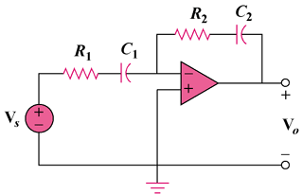

Figure 10.117
For Prob. 10.74.

